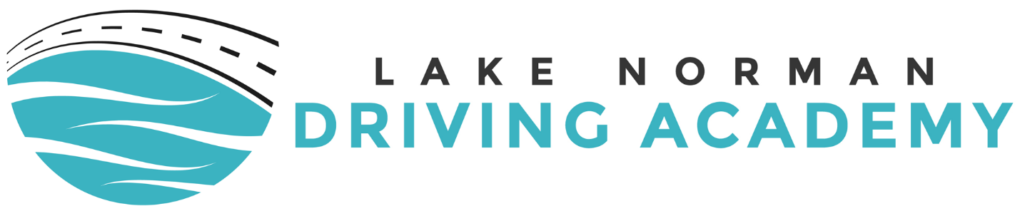
STUDENT DRIVER EDUCATION CONTRACT This contract is made and entered into by and between Lake Norman Driving Academy, LLC, hereafter called the School and hereinafter called the student_________________________________________, for the course in driver education. The school agrees to provide the following for your specific instruction: 30 Hours of in class and 6 Hours of Behind the Wheel. The fee payable for the course is $450 which the sum of $ 450.00 + tax is payable in advance, with a balance due of $0 (full payment) before or on the first day of scheduled class. All books and educational supplies are the property of the school and must be returned in good condition at the completion of the course. The school will complete the course in a reasonable length of time. However, they cannot‐be‐held responsible for delays caused by mechanical failure, unsafe driving conditions due to bad weather, or any other reason over which it has no control. The school will give the student as much notice as possible if any delays become necessary (or foreseen). The school understands that certain hazards and risks are inherent in the operation of motor vehicles. The Student does hereby specifically assume all risk as may be incurred in the normal operation of a motor vehicle during the course instruction. All vehicles are fully covered with liability insurance through Lake Norman Driving Academy. The students hereby FULLY and COMPLETELY releases the School, its agents and employees from any liability whatsoever, and from ANY and ALL claims or causes of action resulting or arising from any damage or injuries suffered by the Student during this course or any extension thereof, to the extent that such claims shall not be covered by the School's insurance coverage. The student hereby further agrees to indemnify and hold the school harmless from any claims made against it for any damages or injury suffered by any person, company, corporation or other entity, growing out of the Student's operation of the School vehicle, or as a result of the Student's course of instruction, to the extent that such a claim isn't covered by the School's insurance coverage. The fees set out herein are guaranteed for (90) days from the date of this contract. The School cannot and does not guarantee that the Student will successfully pass the examination given by the Division of Motor Vehicles upon the completion of the course. The school does agree to exert its best efforts in teaching the student to meet the requirements of the examinations. This agreement constitutes the entire contract between the school and the student, and any verbal assurances or promises not contained herein shall bind neither the school nor the student. The school will not refund any tuition monies or any part thereof when actual services have been rendered. Under this agreement an instructor may not provide behind‐the‐wheel instruction to more than three individual students. This school is licensed by the State of North Carolina, Division of Motor Vehicles.
Student Signature: ________________________________
Parent signature 18 and younger: ____________________________
Contract Date: ______/______/_______

